MPT-7210A

Solar Controller

I. Introduction
MPPT stands for Maximum Power Point Tracking (MPPT), MPPT controller solar charge controller is the traditional loan product upgrade. MPPT voltage generating real-time detection of solar panels to track the highest voltage and current (vi) adjusting the electrical module through extension work state, so that the maximum power output of the system to charge the battery. MPPT controller used in solar photovoltaic systems, coordination of solar panels to charge the battery, is the brain of the PV system.
The controller uses advanced software algorithms initiative rope move, quickly and accurately tracking the maximum power point of photovoltaic panels module voltage, active tracking work at the maximum power point of the solar cell module in order to get more solar energy. Enhance the charging current and power generation.

- The product parameters
（1）Input voltage: DC12-60V
（2）Output voltage: DC15V-90V can be the key to set voltage is continuously adjustable to accommodate 24V / 36V / 48V / 72V battery pack
（3）Output Current: 0-10A key settings can be continuously adjustable
Output Power: 600W maximum output power of best-fit 100W-600W solar panels, the greater the power, MPPT effect is more obvious.
（4）Scope: 20W-600W, applicable 12-60V solar panels to the battery group, lithium battery packs, distributed household photovoltaic power generation systems, solar car wind turbines, solar street lamps.
（5）Module properties: Controller MPPT tracking accuracy and industry-leading conversion efficiency, automatic charge only of management, high efficiency step-MPPT solar panel controller, dedicated to batteries and lithium battery charge management.
（6）Display interface: Color LCD voltage / current / power / charge status.
（7）Mode: MPPT / DC-DC two options. MPPT of photovoltaic panels application, DC-DC step-up power applications.
（8）Charging options: charging mode can be freely set, built and set their own 20 sets of data storage, support of a machine.

3、Wiring
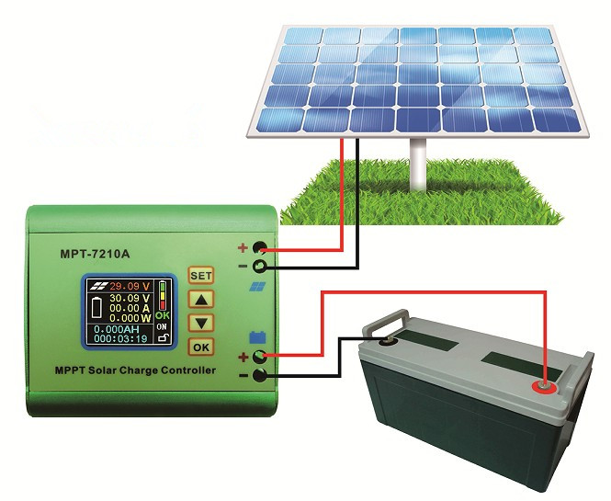
Please note that in strict accordance with the wiring diagram in the instructions, make sure the input and output do not pick the wrong line positive and negative do not quit rice. All electrical equipment must eliminate the live wiring, ranging from live action or line equipment will burn, weight will lead to personal injury and property damage
(1)、the first pick of the solar cell, the positive and negative attention, do not reverse and reverse, the controller does not show that the controller will not damage internal components.
(2)、then connect the battery wires, the positive and negative attention, do not reverse; if there is sunshine, the solar charge current display, otherwise check the connections on the right. Note: The solar panels should be placed outdoors, all illuminated in the sun!
4、Dimensions Mounting Figure
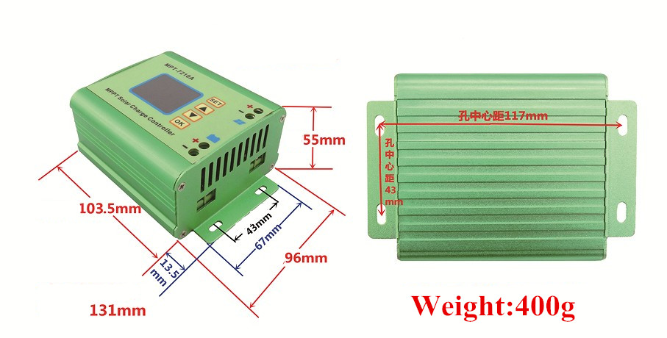
Install the controller at -10 degrees to 60 degrees, a relatively dry environment.
Display devices are easy to pollution easily broken, the installation process and avoid touching the collision force, use screws to secure the controller firmly, avoid installation in order to avoid irreparable damage to the internal circuitry in severe vibration device.
Avoid long-term exposure to the sun, to guard against rain.

5、Panel

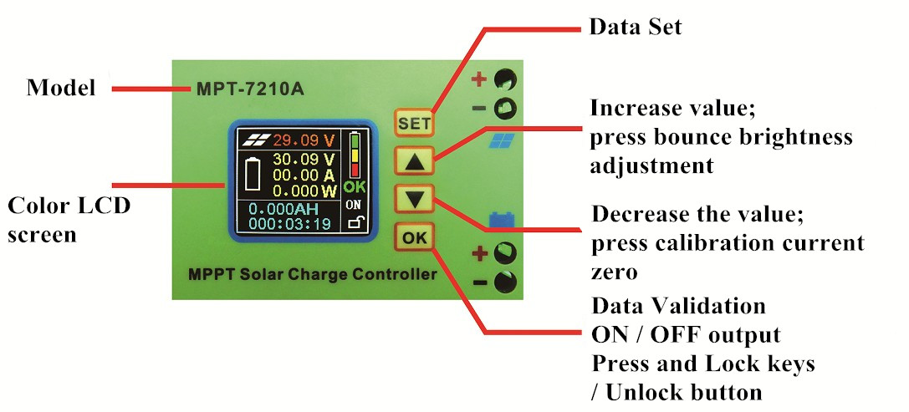

- Display Description

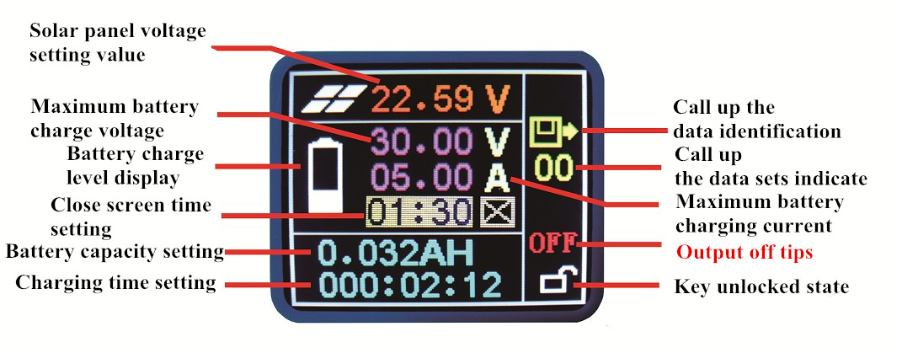
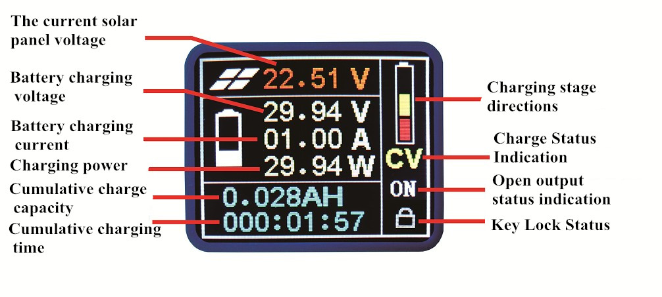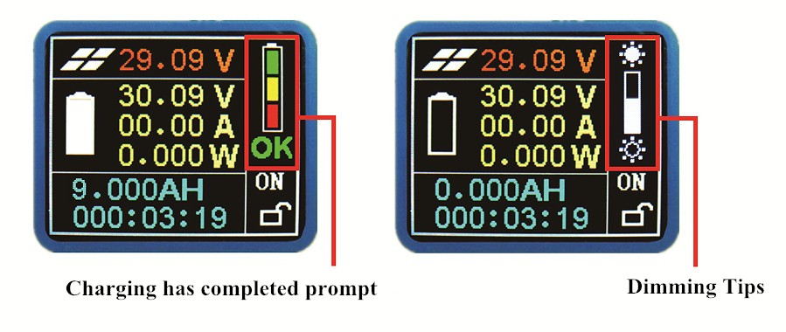
7, the steps

