User's Manual
L60/L80
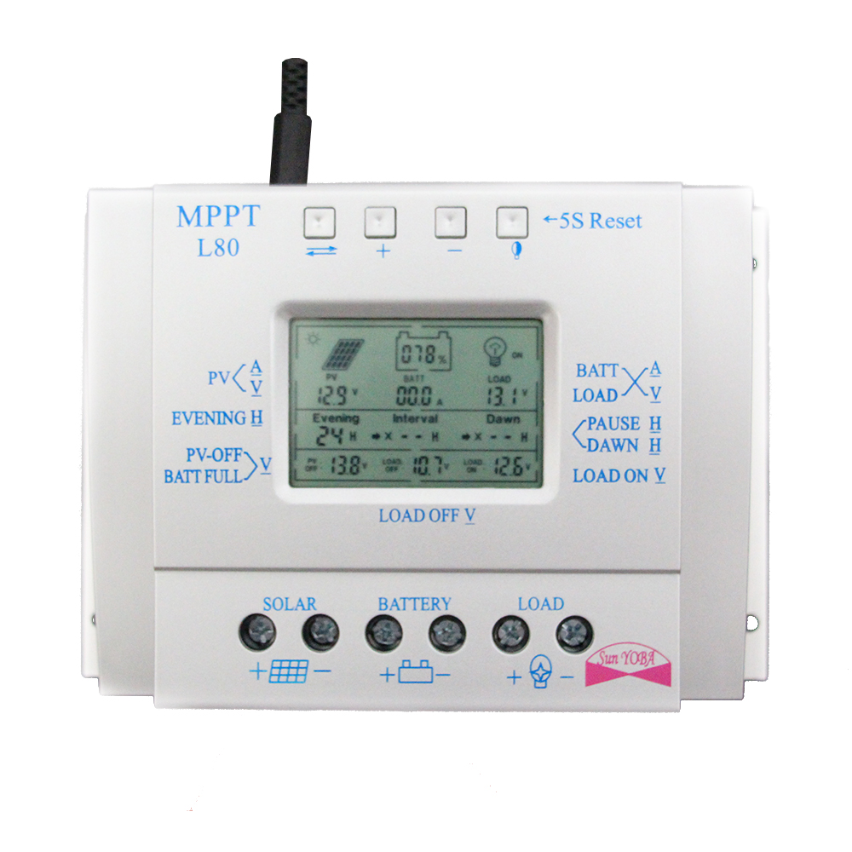

Introduction
This is Three-time Controller into the evening working time,and interval of rest or pause time,Dawn working time(morning light function),the user can according to their needs,set a different time.
A:Time(evening working) B:time(Pause working) C:time(dawn working)
This is a compatibel MPPT charge controller PWM intelligent/efficient/energy saving,it not only has efficient MPPT controller charging function to automotically track the maximum power point,10%-30% higher than the ordinary controller charging efficiency,also has standby energy saving,more than 30% energy than ordinary controller,the standby power consumption of only 10mA-15mA
Features
LCD screen display
Battery reverse discharge protection
Simple(and more time control)operation
Battery reverse polarity protection
PWM charging mode+MPPT
Battery under voltage protection
Parameter user can reset
Overload,short-circuit protection
A key to open and close the load
Automatci Temperature compensation function
A key to restore the factory setting
USB 5V charge(current 1500mA/1.5A)optional

Installation
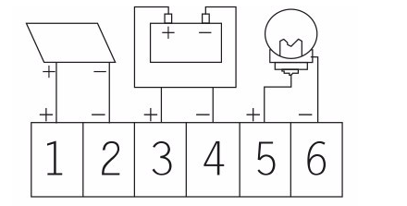
1.Ready Qi installation tools and materials,and cable.Please matching suitable cable
2.Ensure that the current desity<4A/mm2 That will help reduce the line pressure drop.check the installation site meets the relevant safety requirements,avoid damp,dusty,flammable,explosive and corrosive gases
3.Install the controller fixed to the vertical plane,see Section V mounting aperture and hole spacing.In order to ensure a good controller cooling conditions,the controller on the bottom of each reserved 10cm space
4.As shown on the right wiring sequense:load,battery,solar Battery plate is connected to the controller to be taken to ensure that the load,battery,The polarity of the solar cell panel and controller
5. Before use:external temperature sensor probe into the left of the controller temperature probe interface probe placed in similar battery temperature.(Line extensive must be build-in devices of the external temperature probe coextensive Otherwise,the controller will control parameters of the temperature compensation of the error
6.Warning:In order to prevent accidents from occurring,install:non-professionals can not be engaged in loading and unloading operations
7.Charging Problem Solution:
a.No proper installation of solar panels cable polarity(“+””-”) Removing the polarity,you can re-install the correct
b.More than the rated power of solar panels to reduce solar panel power does not exceed the rated power controller discharge Problem Solution
c.Removing the load is not properly connected to the load,re-install the correct
d.More than the rated load power to reduce load power,the controller does not exceed the rated power
e.Instantaneous starting current is too large,the battery capacity is too small,the replacement of high-capacity batteries,button troubleshooting
f.Wire Cable polarity loose or too square and increase retightening bold cable
g.All keys can troubleshoot faults,press 5 seconds to restore factory settings.

Data sheet

