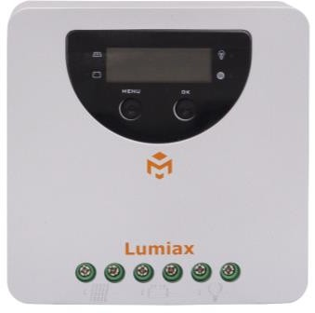
MC2010

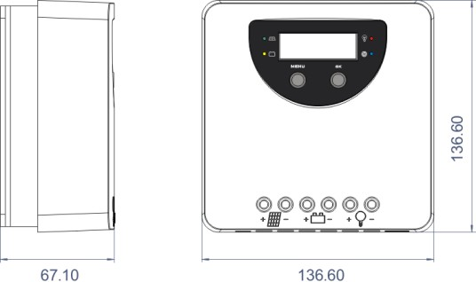
Unit: mm

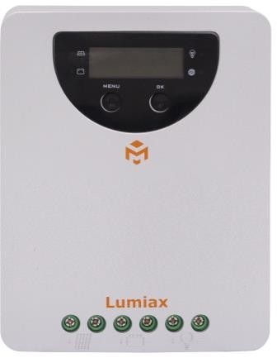
MC4010
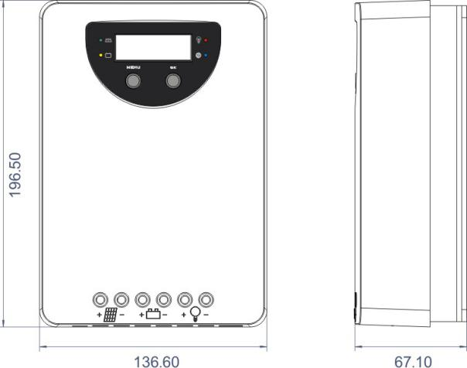
Unit: mm

- A combination of multiple tracking algorithms enables tracking the maximum power point quickly and

accurately
- Innovative Max Power Point Tracking(MPPT) technology, tracking efficiency >99.9%
- Full digital technology, high charge conversion efficiency up to 98%
- LCD display design, read operating data and working condition easily
- Real-time energy statistics function
- 12/24V or 48V automatic recognition
- Flexible System battery selection: Liquid, Gel, AGM and Lithium
- Extends battery life through accurate remote temperature sensor
- Controller is protected against over-temperature due to built-in power reduction function
- Four stages battery charging process: MPPT, boost, equalization, float
- Dual automatic protection to avoid exceeding the rated charging power and current
- Multiple load control modes: Always on, Street lamp, User-defined mode
- IoT wireless communication or Bluetooth (internal or external) communication functions optional
- Optional APP version for Bluetooth communication
- With the wireless communication function of the IoT, the controller can be connected remotely through IoT/GPRS
- Monthly charging data can be calculated and displayed by grouping and graphs
- Based RS-485 standard Modbus protocol with RJ11 interface to maximize the communication needs of different occasions
- Perfect Heat dissipation design
- Full automatic electronic protect function for increased charge controller availability

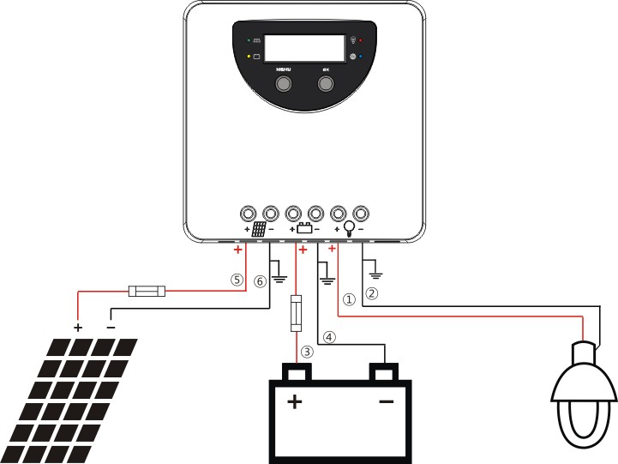

 | Item | MC2010 | MC4010 | MC6015
Battery Parameters | System Voltage | 12V/24V automatical recognization |  | 12V/24V/48V automatical recognization
 | Max Charging Current | 20A | 40A | 60A
 | MPPT Charging Voltage | before boost or equal charging stage
 | Boost Voltage@25℃ | 14.0~14.8V/28.0~29.6V @25℃(default:14.5/29V) |  | 14.0~14.8V/28.0~29.6V/56.0~59.2V(default  :14.5/29.0/58.0V)
 | Equal Voltage@25℃ | 14.0~15.0V/28.0~30.0V @25℃(default:14.8/29.6V)(Liquid, AGM) |  | 14.0~15.0V/28.0~30.0V/56.0~60.0V  (default:14.8/29.6/59.2V)
 | Float Voltage@25℃ | 13.0~14.5V/26.0~29.0V @25℃(default:13.7/27.4V) |  | 13.0~14.5V/26.0~29.0V  /52.0~58.0V(default:13.7/27.4/54.8V)
 | Low Voltage Disconnect | 10.8~11.8V/21.6~23.6V(default:11.2/22.4V) |  | 10.8~11.8V/21.6~23.6V/43.2~47.2V(default  :11.2/22.4/44.8V)
 | Reconnect Voltage | 11.4~12.8V/22.8~25.6V(default:12.0/24.0V) |  | 11.4~12.8V/22.8~25.6V/45.6~51.2V(default  :12.0/24.0/48.0V)
 | Overcharge Protect | 15.8V/31.3V |  | 15.8/31.3/62.3V
 | Charging target voltage | 10.0~32.0V(Lithium, default: 14.4V) |  | 10.0~64.0V(Lithium, default: 29.4V)
 | Charging recovery voltage | 9.2~31.8V(Lithium, default: 14.0V) |  | 9.2~63.8V(Lithium, default: 28.7V)
 | Low voltage disconnect | 9.0~30.0V(Lithium, default: 10.6V) |  | 9.0~60.0V(Lithium, default: 21.0V)
 | Low voltage reconnect | 9.6~31.0V(Lithium, default: 12.0V) |  | 9.6~62.0V(Lithium, default: 22.4V)
 | Temperature Compensation | 35V |  | 65V
 | Battery Type | -4.17mV/K per cell (Boost, Equal), -3.33mV/K per cell (Float)
 | Max Voltage on Battery  Terminal | Liquid, GEL, AGM, Lithium(default: GEL)
Panel Parameters | Max Voltage on PV  Terminal(-20℃) *1 | 100V |  | 150V
 | Max Voltage on PV  Terminal(25℃) | 90V |  | 138V
 | Max Input Power | 260W/520W | 520W/1040W | 750/1500/3000W
 | Dusk/Dawn detect voltage | 8.0V/16.0V |  | 8.0V/16.0V/32.0V
 | MPPT Tracking Range | (Battery Voltage+1V) ~ Voc*0.9 *2
Load  Parameters | Output Current | 20A | 30A
 | Work mode | Always on, Street lamp, User-defined mode
System Parameters | Max tracking efficiency | >99.9%
 | Max charge conversion | 98%
 | Dimensions | 136.6*136.6*67.1mm | 196.5*136.6*97.1mm | 262.5*186.5*97.5mm
 | Weight | 830g | 1300g | 2500g
 | Self consumption | ≤8mA (12V); ≤12mA (24V) |  | ≤16mA (12V); ≤12mA (24V)；≤10mA (48V)
 | Communication | RS485 (RJ11 interface)
 | Optional | IoT、Cyber-BT
 | Grounding | Common Negative
 | Power ternimals | 6AWG (16mm²)
 | Ambient temperature | -20 ~ +55℃
 | Storage temperature | -25 ~ +80℃
 | Ambient humidity | 0~100%RH
 | Protection degree | IP32
 | Max Altitude | 4000m

*1. Maximum solar panel voltage at minimum ambient operating temperature.
*2. Voc: PV-Module open circuit voltage.
*3. Slash separate values for 12V/24V/48V nominal system voltage.

 | Item | MC2010-BT | MC4010-BT | MC6015-BT
Battery Parameters | System Voltage | 12V/24V automatical recognization |  | 12V/24V/48V automatical recognization
 | Max Charging Current | 20A | 40A | 60A
 | MPPT Charging Voltage | before boost or equal charging stage
 | Boost Voltage@25℃ | 14.0~14.8V/28.0~29.6V @25℃(default:14.5/29V) |  | 14.0~14.8V/28.0~29.6V/56.0~59.2V(default  :14.5/29.0/58.0V)
 | Equal Voltage@25℃ | 14.0~15.0V/28.0~30.0V @25℃(default:14.8/29.6V)(Liquid, AGM) |  | 14.0~15.0V/28.0~30.0V/56.0~60.0V  (default:14.8/29.6/59.2V)
 | Float Voltage@25℃ | 13.0~14.5V/26.0~29.0V @25℃(default:13.7/27.4V) |  | 13.0~14.5V/26.0~29.0V  /52.0~58.0V(default:13.7/27.4/54.8V)
 | Low Voltage Disconnect | 10.8~11.8V/21.6~23.6V(default:11.2/22.4V) |  | 10.8~11.8V/21.6~23.6V/43.2~47.2V(default  :11.2/22.4/44.8V)
 | Reconnect Voltage | 11.4~12.8V/22.8~25.6V(default:12.0/24.0V) |  | 11.4~12.8V/22.8~25.6V/45.6~51.2V(default  :12.0/24.0/48.0V)
 | Overcharge Protect | 15.8V/31.3V |  | 15.8/31.3/62.3V
 | Charging target voltage | 10.0~32.0V(Lithium, default: 14.4V) |  | 10.0~64.0V(Lithium, default: 29.4V)
 | Charging recovery voltage | 9.2~31.8V(Lithium, default: 14.0V) |  | 9.2~63.8V(Lithium, default: 28.7V)
 | Low voltage disconnect | 9.0~30.0V(Lithium, default: 10.6V) |  | 9.0~60.0V(Lithium, default: 21.0V)
 | Low voltage reconnect | 9.6~31.0V(Lithium, default: 12.0V) |  | 9.6~62.0V(Lithium, default: 22.4V)
 | Temperature Compensation | 35V |  | 65V
 | Battery Type | -4.17mV/K per cell (Boost, Equal), -3.33mV/K per cell (Float)
 | Max Voltage on Battery  Terminal | Liquid, GEL, AGM, Lithium(default: GEL)
Panel  Parameters | Max Voltage on PV  Terminal(-20℃) *1 | 100V |  | 150V
 | Max Voltage on PV  Terminal(25℃) | 90V |  | 138V
 | Max Input Power | 260W/520W | 520W/1040W | 750/1500/3000W
 | Dusk/Dawn detect voltage | 8.0V/16.0V |  | 8.0V/16.0V/32.0V
 | MPPT Tracking Range | (Battery Voltage+1V) ~ Voc*0.9 *2
Load Parameters | Output Current | 20A | 30A
 | Work mode | Always on, Street lamp, User-defined mode
System Parameters | Max tracking efficiency | >99.9%
 | Max charge conversion | 98%
 | Dimensions | 136.6*136.6*67.1mm | 196.5*136.6*97.1mm | 262.5*186.5*97.5mm
 | Weight | 830g | 1300g | 2500g
 | Self consumption | ≤8mA (12V); ≤12mA (24V) |  | ≤16mA (12V); ≤12mA (24V)；≤10mA (48V)
 | Communication | BlueTooth, RS485 (RJ11 interface)
 | Optional | IoT
 | Grounding | Common Negative
 | Power ternimals | 6AWG (16mm²)
 | Ambient temperature | -20 ~ +55℃
 | Storage temperature | -25 ~ +80℃
 | Ambient humidity | 0~100%RH
 | Protection degree | IP32
 | Max Altitude | 4000m

*1. Maximum solar panel voltage at minimum ambient operating temperature.
*2. Voc: PV-Module open circuit voltage.
*3. Slash separate values for 12V/24V/48V nominal system vol

